Funeral Service
Andover Lutheran Church
Windom, Kansas
Thursday, September 5, 2013, at 10:30 AM

Officiating Clergy
Rev. Thomas Hallowell

Special Music
Congregational Hymns: “Amazing Grace” #448
“My Faith Looks Up to Thee” #479
Solo: “Blessings”
Connie Achilles, vocalist
Jim Pauls, pianist

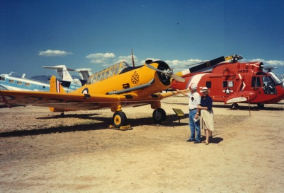
Casketbearers
Brad Bengston Kevin Bengston Shanon Bengston
Vince Bengston Mike Johnson Darrel Thiessen Keith Plooster

Honorary Casketbearers
Rudy Pauls Larry Plooster Danny Benard
John Miller Scott Achilles Brian Kelling Matt Hedberg

Ushers
Curtis Crandall Mike Smyres Arlyn Lindquist

Interment
Andover Cemetery ~ Windom, Kansas
Military Honors by American Legion Post #24 and VFW Post #2715

Memorial Donations
The family suggests that memorial donations be given to Andover Cemetery Fund in loving memory of Evert.

Appreciation
On behalf of the family, we wish to express their sincere appreciation for all your kindnesses, evidenced in thought and deed and for your presence at this service.

Stockham Family Funeral Home

Evert L. Bengston
September 3, 1920 ~ August 31, 2013

E
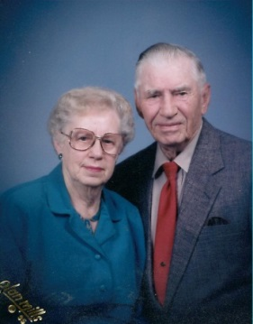
vert Leroy Bengston, son of John W. and Hildur C. (Ekholm) Bengston, was born September 3, 1920, on his parents’ farm near Windom. His parents emigrated from Sweden when they were young, and Evert only knew how to speak Swedish until the time he entered school. He attended the Hayes Township country school and graduated from Windom High School in 1940.
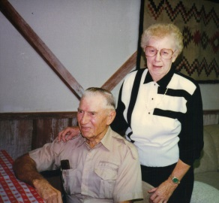
He farmed with his father until World War II. Evert was called by the U.S. government to work at the Boeing Airplane Company, which he did for six months before entering the Army in September of 1942. He was first stationed at Fort Leavenworth and took aircraft mechanic training in Kansas City. During his time in the service, he was also stationed in Victoria, TX, Spokane, WA, and finally at Garden City, KS when the war ended. After the war, he resumed farming with his father. He also worked at the Central Sale Barn in South Hutchinson for 22 years.
On August 3, 1956, Evert was united in marriage to Bernice M. Bowles at the Andover Lutheran Church. They lived in Hutchinson until Bernice’s retirement in 1979, when they moved to the farm near Windom, Kansas. In 2009, Evert and Bernice moved to Hutchinson to an apartment at the Good Samaritan Center.
Evert was a member of the Andover Lutheran Church and American Legion Post #24.
(continued on back)

Evert entered peacefully into eternal rest on Saturday, August 31, 2013, at the family farm near Windom. He was as ninety-two.
Survivors include: three brothers, Arvid Bengston of McPherson, Willard Bengston (Joyce) of Windom, Virgul Bengston (Carole) of Hutchinson; a sister, Gloria Plooster of McPherson; and several nieces, and nephews.
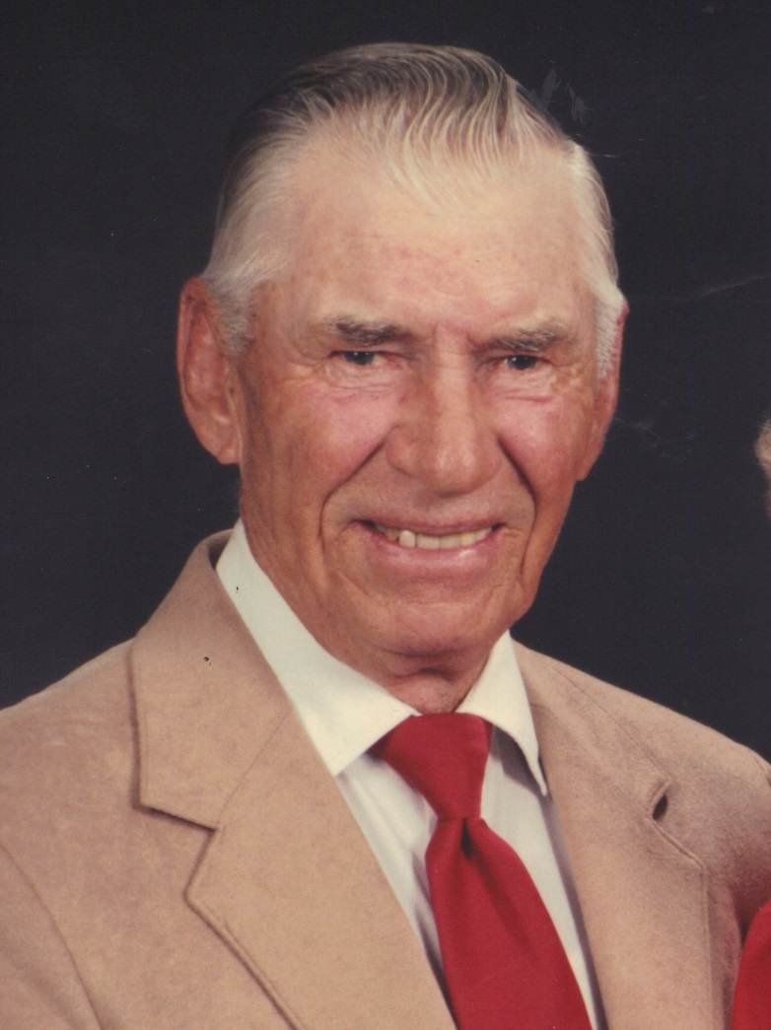
He was preceded in death by his parents, wife, brother, Chester Bengston, sister, Carolyn Hannah, brother-in-law, Marvin Plooster, and sisters-in-law, Marcia Bengston and Treva Bengston.

Ecclesiastes 3: 1-8

To everything there is a season, and a time to every purpose under heaven:

A time to be born, and a time to die; a time to plant, and a time to pluck up that which is planted;

A time to kill, and a time to heal; a time to break down, and a time to build up;

A time to weep, and a time to laugh; a time to mourn, and a time to dance;

A time to cast away stones, and a time to gather stones together; a time to embrace, and a time to refrain from embracing;

A time to get, and a time to lose; a time to keep, and a time to cast away; a time to rend, and a time to sew; a time to keep silence, and a time to speak;

A time to love, and a time to hate; a time of war, and a time of peace.

In Loving Memory
Evert Leroy Bengston

1920 ~ 2013

