Funeral Service
Stockham Family Funeral Home
McPherson, Kansas
Saturday, February 18, 2012, at 11:00 AM

Officiant
Rev. Michael Marion

Special Recorded Music
Patti’s tribute: “How Do I Live Without You”
by Trisha Yearwood
“Through the Years” by Kenny Rogers
“If I Had Only Known” by Reba McEntire
“Rest of Mine” by Trace Adkins
Sons’ tribute: “That’s My Job” by Conway Twitty

Special Readings
Poems: “Footprints”, read by Donielle Andreas
“To Those Whom I Love and Those Who Love Me”,
read by Carol Wagner
Brother Dedication: by Jason Eagle
“Final Flight”, read by Jessica Petersen
Friendship Dedication: by Bob Leazenby

Casketbearers
Jason Eagle Lonnie Wagner Mikel Andreas
Donald Wagner Eric Wagner Ray Price, Jr.

Honorary Casketbearers
Christopher Eagle Bradly Eagle
Robert Holm Bob Leazenby

Interment
New Gottland Lutheran Church Cemetery
Military Honors presented by the Honor Guards of Fort Riley, V.F.W. Post #2715, and American Legion Post #24.

Memorial Donations
The family suggests that memorial donations be given to the First United Methodist Church, McPherson or Harry Hynes Memorial Hospice in loving memory of Mike.

Donald “Mike” Eagle
October 28, 1953 ~ February 15, 2012

D
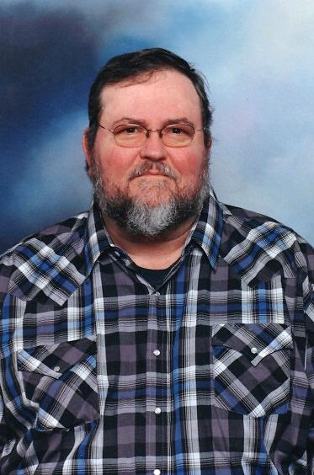
onald “Mike” Eagle, 58, of Galva and formerly of McPherson, passed away on Wednesday, February 15, 2012, at Harry Hynes Memorial Hospice Center at St. Francis Regional Medical Center, Wichita.
Mike served in the United States Army from 1972 to 1978. He had worked at Midwest Industries, McPherson as a welder.
Mike was born on October 28, 1953, in Parkersburg, West Virginia, the son of Rufus and Norma Jean (Virden) Eagle. He attended the local schools in Parkersburg, WV and received his high school diploma in Junction City, KS. On March 12, 1978, he was united in marriage to Patti Sue Wagner in Wakefield, Kansas. In 1979, the couple moved to McPherson, KS and in 1993, they moved to Galva, KS.
Mike’s hobbies included hunting, fishing, trapping, knife making, and guns. However, spending time with his family, especially his grandchildren and friends was his biggest love.
Survivors include: his wife, Patti of the home; sons, Christopher Eagle and wife, Dawn, of McPherson, KS and Bradly Eagle and wife, Heather, of Canton, KS; daughter, Heather Eagle of Parkersburg, WV; niece, Jennifer Brandon and husband, Josh, of Texas; brothers, Mark Eagle and wife, Veda, Randy Eagle and wife, Sherry, Jason Eagle and wife, Susy, and Tracey Eagle all of Parkersburg, WV; sister, Martha Vanfossan of Parkersburg, WV; 17 grandchildren; and several nieces & nephews.
Mike was preceded in death by his parents, Rufus Eagle and Norma Jean Eagle-Anderson, grandparents, Howard & Ethel Virden and Robert & Minnie Eagle, granddaughter, Michaela Sue Eagle, and grandson, Daniel.
Mike will be dearly missed by all who had the privilege of knowing and loving him.

Miss Me But Let Me Go

When I come to the end of the road
And the sun has set for me
I want no rites in a gloom filled room
Why cry for a soul set free?
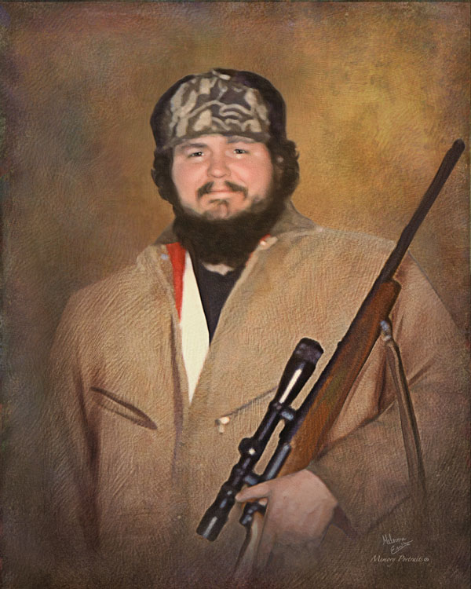
Miss me a little – but not too long
And not with your head bowed low
Remember the love that we once shared
Miss me – but let me go.

For this is a journey that we all must take
And each must go alone
It’s all a part of the Master’s plan
A step on the road to home.

When you are lonely and sick at heart
Go to the friends we know
And bury your sorrows in doing good deeds
Miss me - but let me go.

Appreciation
On behalf of the family, we wish to express their sincere appreciation for all your kindnesses, evidenced in thought and deed, and for your presence at this service.

Following the burial, the family would like to invite everyone for a time of food & fellowship at the First United Methodist Church, 1200 East Kansas Avenue, McPherson, KS 67460.

Stockham Family Funeral Home

Forever in Our Hearts
Donald “Mike” Eagle

1953 ~ 2012

