Funeral Service
First Christian Church
McPherson, Kansas
Tuesday, January 31, 2012, at 1:00 PM

Officiating Clergy
Rev. Tripp Edwards

Special music
“Breathe”, by Taylor Swift & Colbie Caillat
“He Didn’t Have to Be”, by Brad Paisley

Casketbearers
Ross Prough Randy Redinger Kirk Roberts
Mike Schulz Rick Shober Randy Smith

Honorary Casketbearers
Jake Hampton Menno Loepp
Print Shop co-workers

Ushers
Bill Adams Arnold Carter Rick Walker

Memorial Donations
The family suggests that memorial donations be given to Pleasant View Home (Inman) or Hospice Care of Kansas (McPherson) in loving memory of Jimmy.

Appreciation
On behalf of the family, we wish to express their sincere appreciation for all your kindnesses, evidenced in thought and deed, and for your presence at this service. The family would like to extend a special thank you to Dr. DeWitt and his staff, Hospice Care of Kansas CIT team, and all the guys in the Print Shop for the love and care given to Jimmy during his illness.

Stockham Family Funeral Home
Jimmy Lee Flood, Jr.

J
immy Lee Flood, Jr., son of Jimmy Lee, Sr. and Glova Ruth (Linaweaver) Flood, was born July 25, 1958, in McPherson. He was one of three children born to the family. Jimmy attended the local schools and graduated from McPherson High School in 1977.
He worked for Hutchinson Correctional Facility for over 22 years, most recently as the Print Shop Supervisor, a position that used to be held by his father. Jimmy really loved his job and took great pride in his work, while also acting as a mentor for the inmates. Prior to his work at the prison, Jimmy owned and operated the Gambler Bar & Casino in McPherson.
On December 22, 1987, he was united in marriage to Gina S. (Ensz) Robertson in Miami, OK. Each of them brought a daughter into the marriage and a third was soon added. The three girls kept Jimmy very busy with their various school and sports activities.
He raised them to be independent and practical. Christmas gifts for them were always tools, guns, other gifts typically given to boys. He was a good provider for the girls, and they always had the best, even if it meant he had to go without. The girls considered him to be their personal coach, not just for basketball, but also for life’s other endeavors. One thing he always preached to them was, “It’s not what you know, it’s who you know!” In more recent years, Jimmy loved spending time with his grandchildren, Cora and Kustom, and he dearly adored them.
Though the last few years of his life were challenging, he always had a way to make the difficult situations seem not so bad. In spite of his physical limitations, he never gave up and insisted on doing the things he wanted to do, despite the risks.
After a lengthy period of failing health, Jimmy entered peacefully into eternal rest on Thursday, January 26, 2012, at his home in McPherson. He was fifty three.
Survivors include: his wife, Gina of the home; daughters, Jennifer Flood of Kansas City, Melissa Schamp (Shane) of Galva, KS, and Molly Flood of McPherson, KS; parents, Jim and Glova Flood of Many, LA; grandchildren, Cora and Kustom Schamp of Galva, KS; sisters, Tammy Ek (Steve) of Many, LA and Debbie Flood of Many, LA; father-in-law & mother-in-law, Robert and Jo Ensz of McPherson, KS. He was preceded in death by his grandparents, Vera and Forest Linaweaver and Robbie and Bert Flood.

To Those I Love

When I am gone, release me, let me go…
I have so many things to see and do.
You mustn’t tie yourself to me with tears,
Be happy that we had so many years.
I gave you my love, you can only guess
How much you gave to me in happiness.
I thank you for the love you each have shown,
But now it’s time I traveled on alone.
So grieve awhile for me, if grieve you must
Then let your grief be comforted by trust.
It’s only for a while that we must part.
So bless the memories within your heart.
I won’t be far away for life goes on
So if you need me, call and I will come.
Though you can’t see or touch me, I’ll be near…
And if you listen with your heart you’ll hear.
All of my love around you soft and clear.
And then, when you must come this way alone,
I’ll greet you with a smile, and “Welcome Home.”

In Loving Memory

Jimmy L. Flood, Jr.

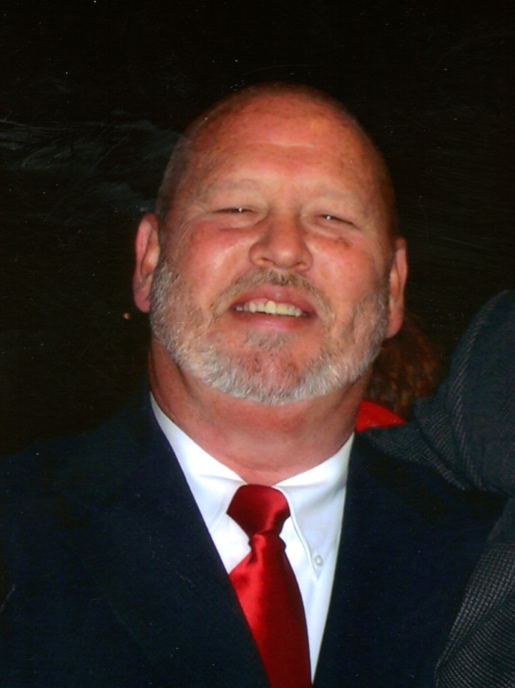

1958 ~ 2012

