Funeral Service
McPherson Free Methodist Church
D
Friday, March 23, 2012, at 10:30 AM.

Officiating Clergy
Rev. Deborah Somerville
Rev. Tom Griffith

Special Music
”My Jesus I Love Thee”
Judy Potter, vocalist
Recording: “It’s True”
Congregational Hymns: “Amazing Grace” #202
“How Firm a Foundation” #275
Carol Ruth Hadduck, organist

Interment
McPherson Cemetery ~ McPherson, Kansas

Casketbearers
Galen Shields Elmer Hanson Denis Everhart
Les Hargadine Homer Yowell Eugene Brandt

Ushers
Merlin Fields Ken Luginsland

Memorial Donations
In lieu of flowers, the family suggests that memorial donations be given to Central Christian College of Kansas in loving memory of Dorothy.

Appreciation
On behalf of the family, we wish to express their sincere appreciation for all your kindnesses, evidenced in thought and deed, and for your presence at this service.

Stockham Family Funeral Home

Dorothy May (Henkle) Pounds
May 30, 1914 ~ March 15, 2012

orothy was born May 30, 1914, in Kay County, Oklahoma, the daughter of William H. and Myrtle (Mitcham) Henkle. She graduated from Central Academy, McPherson in 1931, Central College, McPherson in 1935, Seattle Pacific, WA with a B.A. degree in 1946, and Wichita State University with a M.A. degree in 1960.
Following the lead of two of her sisters, Dorothy chose to become a teacher and completed 42 years in the teaching profession. Starting with nine years teaching in elementary school settings, she later chose to teach math and English in junior and senior high schools in LaCygne, McPherson, Wichita, and Arkansas City.
Dorothy worked with a wide variety of students of different ages and at various levels. She could recognize their sensitivities and helped all to reach their full potential. Her career culminated by induction into the Kansas State Teachers Hall of Fame.
Her memberships included the Free Methodist Church, where she played the organ and piano, Gideons Auxiliary, McPherson Association of Retired School Personnel (past President), the Kansas Association of Retired School Personnel (past President), and Delta Kappa Gamma (past Treasurer).
On May 3, 1986, Dorothy married Roger W. Pounds. During their union, they traveled extensively throughout the U.S. and the Orient. Roger preceded her in death on February 10, 2009.
Dorothy was saved at an early age and remained a faithful servant of her Lord and her church throughout her life. She was a loving aunt to her nieces and nephews and their families; and a devoted step-mother to Roger’s daughters and their families.
Dorothy passed away on Thursday, March 15, 2012, at Hutchinson Regional Medical Center. She was ninety-seven.

(continued on back)
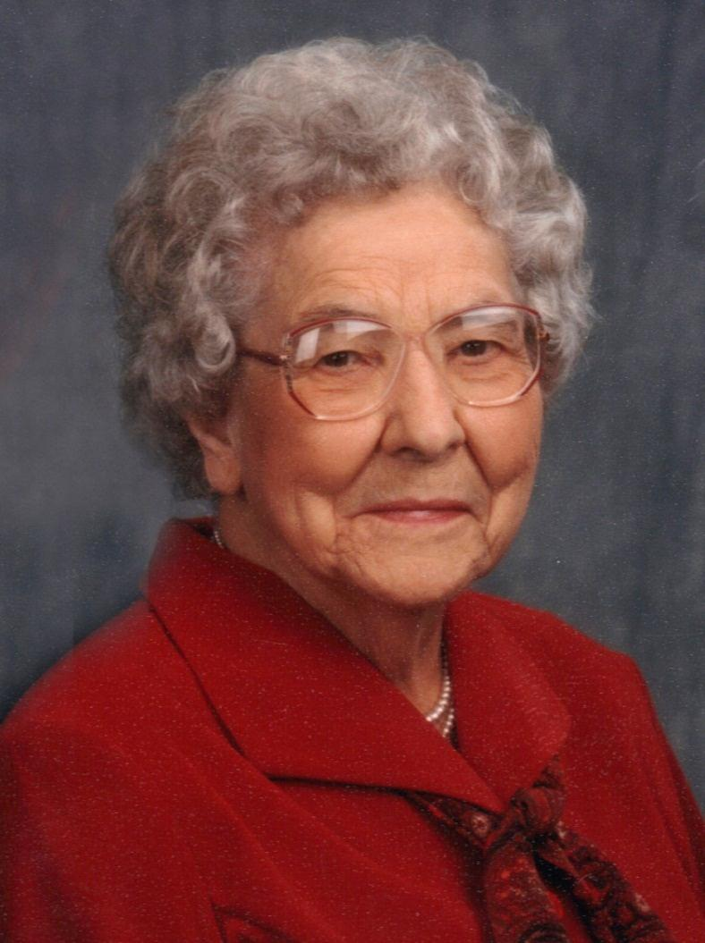
Survivors include: step-daughters, Erma C. Dunham & husband, Calvin, of Russellville, Arkansas and Elma M. Habecker & husband, Earl, of Spring Arbor, Michigan; nephews, Marvin Sellberg of McPherson, Kansas, James Henkle of New York, Richard Henkle of Garden City, Kansas, and Steven Henkle of Orange, California; nieces, Joyce Boone of Garden City, Kansas and Kay Mylod of Huntington Beach, California; great-nephews, Dr. Martin Sellberg of Wichita, Kansas and Gary Bricker of Wichita, Kansas; great-nieces, Marcia (Sellberg) Meyer of Paradise Valley, Arizona and Marlene (Sellberg) Waltz of Kansas City, Missouri; eight step-grandchildren; and 19 step-great-grandchildren. She was preceded in death by her parents, seven siblings, and her husband.

GOD
MADE
TEACHERS

who teach by their deeds
and by what they say.
Who help students learn truth,
to choose right from wrong,
to embrace wisdom,
and to grow in understanding,
By being for them a living lesson
from God’s textbook of life.

“Study to show thyself
approved unto God.”
II Timothy 2:15

In Loving Memory
Dorothy May Pounds

1914 ~ 2012

