Memorial Service
McPherson County Old Mill Park & Campground
Lindsborg, Kansas
Saturday, April 2, 2011, at 5:00 PM

Officiating Clergy
Rev. Tim Carey

Special Music
Recorded Music:
“Big Train” by Mike Watt
“Here Comes a Regular” by The Replacements
“Lawyers, Guns, & Money” by Warren Zevon
“Gray” and “Runnin”, by The Heartless Bastards
“Caribou” by The Pixies

Memorial Donations
The family suggests that memorial donations be given to American Diabetes Association in loving memory of Josh.

Appreciation
On behalf of the family, we wish to express their sincere appreciation for all your kindnesses, evidenced in thought and deed, and for your presence at this service.

Stockham Family Funeral Home
Joshua J. Balzer
October 18, 1974 ~ March 26, 2011

J
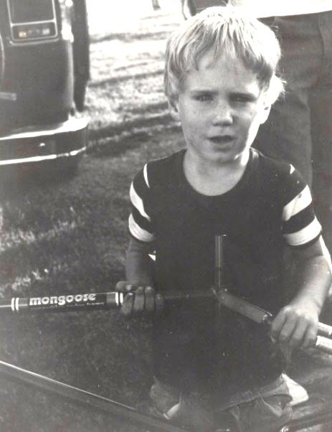
oshua J. “Josh” Balzer was born on October 18, 1974, in Hillsboro, Kansas, the son of Thomas Allen and Janet Kay (Alger) Balzer. He graduated from McPherson High School in 1993 and later went on to graduate from culinary school.

He was a former Chef at Murray’s Steak House in Minneapolis, MN and also was a Herpetologist (studied, bred, and raised reptiles and amphibians).

Josh was a son, brother, grandson, nephew, uncle, and step-brother. He developed a love for music and animals at a very young age. He once saved a mouse that was floating down a creek when he was only five years old. Wherever he went, he always had to look for frogs or snakes. His pockets always had to be checked before washing them.

Josh was very sensitive. He saw everything and stored it in his mind. Wherever he went, he met people that would forever be his friends. You could never forget that big smile and those blue eyes of his. He loved to make people laugh, whether it be tasteful or not. On the other hand, he was also a good listener, always present for anyone that needed him. While living in Lindsborg, he was introduced to Hyllingsfest. During the first year, being a Swedish dancer was not his favorite thing. However, years later, he was upfront and in the best costume. He loved it. When Josh was happy, all you could see was that smile and the sparkle in his eyes.
As Josh got older, his interests grew. Among some of his interests
(continued on back)
were playing saxophone, go-carts, mopeds (yes, he was one of the pack during the moped days), fishing, girls, baseball, football, soccer, weight-lifting, wrestling, trap-shooting with his dad and brother, watching movies, going to concerts, different schools, cooking, and loving a child. Whatever Josh did, he was good at it. His fault was that he had so many interests and was passionate with each and every one of them. He also was a collector of many things and liked to have his collections close to him.


Josh was introduced to doctors at a very young age. With his health, accidents, and other things that were out of his control, it seemed he had angels watching over him many, many times. But for Josh, that was just the way it was and had to be. He was always looking for that new experience. He was very spiritual, seeing God’s work in everything, from song lyrics to the smallest of creatures. Sometimes Josh would say that people may not understand him, but he could always understand them.

Josh entered into eternal rest on Saturday, March 26, 2011, at his home in Lawrence. He was thirty-six.

Survivors include: his mother, Janet Balzer-Schroeder of McPherson; his father, Tom Balzer (Phyllis) of South Hutchinson; a brother, Chad Balzer (Heike) of Weinstadt, Germany; a nephew, Nick Balzer of Weinstadt, Germany; grandmothers, Ιlo McKenzie and Loel Balzer, both of Hutchinson; step-sisters, Dianne Schroeder, Jessica Schroeder, and Mollie Schroeder-Powell; step-brothers, Matt Schroeder and Josh Fischer; and girlfriend, Corrina Weyland of Lawrence.

Josh was preceded in death by his step-father, Tim Schroeder.

Forever in Our Hearts
Joshua J. Balzer
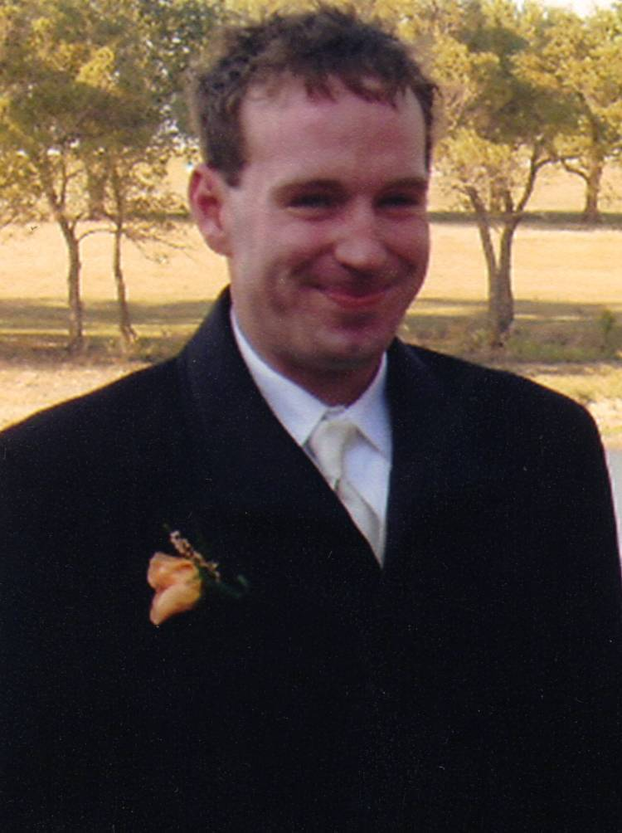

Oct. 18, 1974 ~ March 26, 2011

